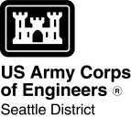
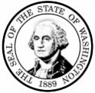
AGENCY USE ONLY

Date received:

Agency reference #:
Tax Parcel #(s):

WASHINGTON STATE
Joint Aquatic Resources Permit
Application (JARPA) [help]

Attachment C:
Contact information for adjoining property owners. [help]
TO BE COMPLETED BY APPLICANT [help]

Project Name:
Location Name (if applicable):

Use this attachment only if you have more than four adjoining property owners.

Use black or blue ink to enter answers in white spaces below.
1. Contact information for all adjoining property owners. [help]
Name | Mailing Address | Tax Parcel # (if known)

If you require this document in another format, contact the Governor’s Office for Regulatory Innovation and Assistance (ORIA) at
(800) 917-0043. People with hearing loss can call 711 for Washington Relay Service. People with a speech disability can call (877) 833-6341. ORIA publication number: ORIA-16-014 rev. 10/2016

